Head of Drama

Required January 2023
Candidate information

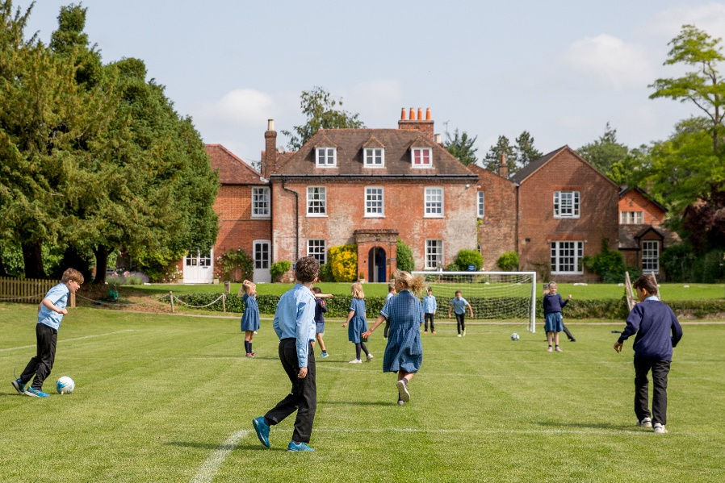

Welcome
Thank you for taking the time to consider an application to be the Head of Drama at Twyford School.
Our parents and staff say that Twyford School is one of those truly special places, where they and their children make friends for life. There is an exceptional feeling of community amongst staff and parents, combined with a drive and ambition to deliver a modern education and a tailored experience to develop every child.
Twyford is a school with a great reputation, supported by a Governing Body which is keen to maintain and enhance its status as one of the top prep schools in the area.
The School
Twyford School is a successful co-educational independent day and flexi-boarding school for pupils aged 2-13 years. Situated in the village of Twyford, near Winchester, and set within a truly enviable position of 25 acres of mature grounds, surrounded by stunning Hampshire countryside, the School prides itself on being one of the oldest prep Schools in the country.
Twyford School moved to its present site, with a beautiful Queen Anne house as its centrepiece, in 1809, but there are links to an educational establishment in Twyford village in the 1790s.
The house and early additions, including the original School room (now Upper School), the Victorian chapel, the old dining hall and the 1920s oak-panelled Memorial library, all bear testament to the School’s long and illustrious history. Excellent modern classroom facilities, cared for gardens and orchard, extensive playing fields and exceptional sports pitches (including an AstroTurf and training facilities), a large modern sports hall and indoor 20m swimming pool, all-weather netball and tennis hard courts all allow for a perfect blend of innovative indoor and outdoor learning experiences.
We have recently opened a new boarding facility, Orchard Close, which sits adjacent to our current premises within 2.36 acres of beautifully established grounds. The opening of this bespoke boarding house has realised our vision to deliver a ‘state of the art’ modern boarding facility, allowing us to extend our flexi-boarding opportunities to the many more children wishing to experience this at Twyford.
Classrooms are large, bright and well equipped, spread across the numerous modern buildings built over the last 20 years in addition to specialist subject rooms including science laboratories and IT facilities. The light, spacious and purpose-built art and design studios have been extended, refurbished and re-equipped in 2020. A dedicated music school has 8 individual teaching rooms alongside a recital hall. The ‘Saxon Court’ complex (the building of which in 2009 unearthed a Saxon burial ground of 18 graves) is a dedicated space for our Year 8s. The Pre-Prep has its own hall, library, art, music and cookery rooms but also uses many of the prep facilities.
In the 1980s, a new dining hall was built to accommodate all members of the pre-prep and prep communities and a versatile space known as the ‘Mulberry Pavilion’ is used for dance, clubs, drama workshops, art exhibitions and CE exam space.
Twyford School offers an exceptional, all-round education to approximately 400 pupils, of which around 100 are flexi or weekly boarders. The overriding aim is to ensure that pupils are actively engaged and intellectually stimulated in a safe and welcoming environment.
One of Twyford’s strongest selling points is its commitment to being a kind, caring, family community with a shared purpose. We are looking to the future by building on our unique ethos and traditional values, to help pupils achieve excellence during their time with us, and to build on this foundation through their teenage years when they head to many of the top independent schools across the UK.
The breadth of opportunity offered to pupils creates a vibrant atmosphere of excitement and endeavour. Music, art, drama, sport and outdoor learning all contribute to the mix and are played out in Twyford’s fantastic surroundings and well-resourced facilities.
The Drama Department
At Twyford we strive to produce a creative and exciting programme of drama, with every child having a dedicated timetabled drama lesson each week, taught by our Head of Drama.
Twyford offers a large range of after school clubs. Drama clubs are an important part of this programme, and the Head of Drama will be expected to run after school clubs over different evenings for pupils in Years 3 to 8.
We have a wide variety of annual productions, with Year 6 and 7 musicals and a Year 8 finale performance. Year 4 and 5 pupils put on a showcase performance for their parents towards the end of the summer term and the Year 3 pupils perform in their annual nativity play at Christmas. The Head of Drama will also be expected to support Pre-Prep productions and plays.
We are looking to extend and develop productions in the coming years to raise the profile of drama and continue to increase participation.
We also offer to all children English Speaking Board exams to younger pupils and LAMDA exams to pupils in Years 5 – 8.
Drama is an ambitious, thriving department integral to life at Twyford School, and we have exciting plans to provide a dedicated theatre in the future to further enhance our provision.

JOB DESCRIPTION
Head of Drama
Reporting to: Headmaster via the Deputy Head Academic.
Purpose & scope of the role
Delivering outstanding teaching and leadership of drama, fostering and encouraging a love of drama in our pupils.
Undertaking a major role in the co-curricular programme at Twyford School, producing a wide variety of performance opportunities for pupils of all abilities.
Encouraging children to engage in forms and styles of performance theatre that stretch and challenge their existing and innate performance skills.
Responsibilities & Key Duties
- Leading the drama department, shaping the direction and promoting the subject across the whole School
- Putting on productions
- Overseeing LAMDA
- Delivering highly inspirational drama lessons which implement curriculum intent and deliver excellent outcomes (both academic and pastoral) for all learners
- Taking drama clubs
- Ensuring that all tasks and activities are clearly linked to intended learning – everything with a purpose, empowering those most in need
- Engaging fully in a culture of continual professional development and coaching
- Any other duties as reasonably requested by the Headmaster or Bursar

Person Specification
The successful candidate will:
- Have a good understanding of curriculum developments within drama
- Have experience of teaching drama and of leading a team (desirable)
- Be able to deliver creative and engaging lessons
- Have good organisational and communication skills
- Display flexibility and adaptability, particularly showing commitment to Twyford School drama productions
- Be a strong communicator, both orally and in writing
- Be experienced at reflecting on their own personal strengths and areas for improvement
Employment Terms and Conditions
The package will include:
- A competitive salary commensurate with experience.
- A discount on fees for the successful candidate’s children starting after the completion of the probation period
- Generous pension provision
- Group Income Protection
- Group Life Assurance
- CPD opportunities

Applicants must be willing to undergo child protection screening appropriate to the post, including checks with Disclosure and Barring Service (DBS) and the barred lists.
Shortlisted candidates will be asked to undertake identity and qualification checks which conform to our safeguarding and child protection policies.
They must also agree to references being taken up at that stage and checks made with past employees.
The successful applicant will be required to complete a self-disclosure medical questionnaire.
The appointment is subject to satisfactory references and security checks, clearance from the DBS, proof of identity and qualifications and a medical declaration.

Application process

Interested candidates should complete the application form available on www.twyfordSchool.com/Schoolinformation/vacancies together with a covering letter addressed to:
Mr Andrew Harvey, Twyford School, Twyford, Winchester, Hampshire SO21 1NW

Please email both documents to Carolyn Godrich, HR Manager at hr@twyfordSchool.com.

The closing date for applications is 12 noon on Wednesday 25th May 2022.

All applications will be acknowledged by email. If you have not received acknowledgement that your application has been received within two working days of sending it, please contact hr@twyfordSchool.com.
Twyford School is committed to safeguarding and promoting the welfare of children, and applicants must be willing to undertake children protection screening appropriate to the post including checks with past employers and the Disclosure and Barring Service (DBS).

